Treasure SAE

Evaluation Plan
Purple Team:
Melanie Blackman, Stephanie Hulsey,
Sharon Laidlaw, Danielle Travis, Matthew Whittlesey
March 18, 2018

Table of Contents:
Introduction and Background | 3
Evaluation Purpose | 4
Stakeholders | 4
Logic Model | 5
Evaluation Questions | 8
Data Collection and Analysis Plans | 11
Logistics and Timeline | 15
Evaluation Budget | 16
Appendix A: Expert Heuristic Evaluation Tool | 17
Appendix B: Learner Survey | 21

Introduction and Background
In all 50 states, middle- and high-school students take classes in agricultural literacy. In addition to traditional classroom learning, these agricultural literacy courses also include hands-on, project-based learning called supervised agricultural experiences (SAEs). SAEs take place in collaboration with community partners.

These community partnerships are arranged by the agricultural literacy teachers, and they require teachers to network and create connections throughout their county. Because high school agricultural literacy teachers must devote many hours beyond the school day to cultivating and maintaining these community partnerships, they are paid for 60-hour weeks. Still, despite the increased compensation, these teachers experience burnout—high levels of frustration, fatigue, and disillusionment.

In response to this burnout, a team of professors at the University of Georgia (UGA) in Athens—one of two Georgia institutions that provide professional learning for preservice agriculture teachers—began exploring ways to improve the teachers’ experience of supervising SAEs. Led by Dr. Eric Rubenstein in the Department of Agricultural Leadership, Education, and Communication in the College of Agricultural and Environmental Sciences, this team of researchers received a USDA/National Institute of Food and Agriculture grant to develop an SAE professional development program called “TREASURE” in which an online game is used as part of the program to better prepare agricultural literacy teachers for the work they do to support SAEs.

The goal of the online game is for game players (i.e., agriculture teachers) to collect as many SAE opportunities as possible without being burnt out, while engaging in short simulations of five different scenarios. Teachers role-play as they learn about their community/county—its history, its main industries, and whether it is rural or suburban. They then use that information to determine networking opportunities and connections within the community. In each of the simulations, the game tells learners if the decisions they make are beneficial to the development of community partnerships, or detrimental. Meters displayed as bars in the game interface tell learners how much community credibility they are building, contrasted with how much burnout they are experiencing.

Dr. Lloyd Rieber, the primary developer of the game, used a rapid prototyping model during the design phase. An initial alpha test was conducted, with approximately 30 teachers. This first test resulted in some qualitative feedback:
- Some individuals were able to “win” the game by getting around its requirements, rather than actually learning as they progressed through the levels. Similarly, learners reported that they could make decisions in the game without actually having enough “credibility” to do so, according to the rules.
- Learners requested more feedback throughout the simulation, in order to enhance their understanding of which decisions were beneficial and why.

As a result of alpha testing, some initial adjustments to the game have already been made. This evaluation will help inform future iterations.

Evaluation Purpose
The main purpose for this evaluation is to inform future improvements to the game, with a secondary purpose being to prepare instruments to evaluate learner responses in the future. For our evaluation purposes, we do not have access to learners, so while we not be able to evaluate them directly, we plan on creating the tools in order for someone else to evaluate them efficiently in the future.

In order to inform future improvements, we will evaluate the interface and determine its attractiveness, the usability and it’s ease of navigation, and if there are any flaws to the game, and if they could be a possible detriment to learners.

The findings from this evaluation will be used to determine next steps in creating and refining the e-Learning game.

Stakeholders
Table 1. Stakeholder Information
Stakeholders | Importance Level | Perspective of Interest | Role in the Evaluation
Dr. Rubenstein and the grant team | Secondary | To ensure the success of this grant-funded project. | To provide our team with any pertinent details involving the grant, learning objectives of the game, goals, and to inform us of the scope of the project.
Dr. Rieber | Secondary | To inform future iterations and decisions regarding the future of the game. | To inform our team of any relevant background information about the design and development of the game.
Dr. Newberry | Primary | Overall efficacy of the e-Learning game as it pertains to the success of pre-service agriculture teachers | Subject matter expert, to inform our team of the relevant background information needed to complete the evaluation; also will act as liaison to target learners who will participate in the evaluation
Pre-service Agriculture Teachers | Secondary | Real life application and transfer of knowledge of game to real life | On the user end of the evaluation; not involved in the planning of it, but feedback will be used to guide future decisions.

Logic Model
Researchers at the University of Georgia have developed an e-learning game in response to the need for professional development for agricultural teachers. In order to accommodate the busy schedules of teachers, the e-learning game is delivered online and in an asynchronous format. To begin the game, teachers must select one of four community profiles. Each profile provides pertinent details which help the teachers make decisions in the game.

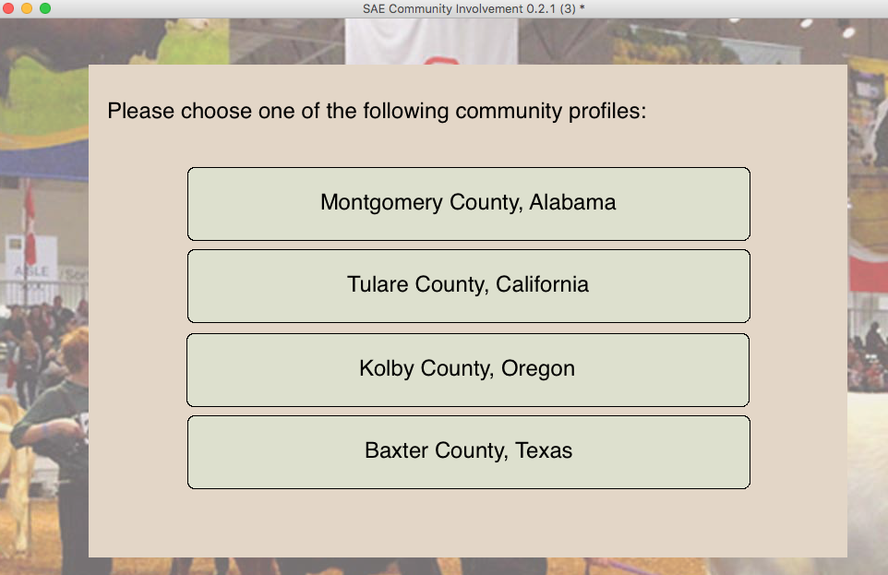

By clicking “Continue,” the teacher navigates to an SAE Community Involvement screen. This screen has three layers. At the top of the screen, the Community Involvement Dashboard keeps track of the teacher’s involvement through an Engagement Meter and SAE Project Timeframe. The Decision Making Dashboard provides community support and multiple choice responses to the question: “What will you do to build community engagement?” Finally, the Teacher Dashboard at the bottom tracks the teacher quality of life, credibility, and SAE opportunities.

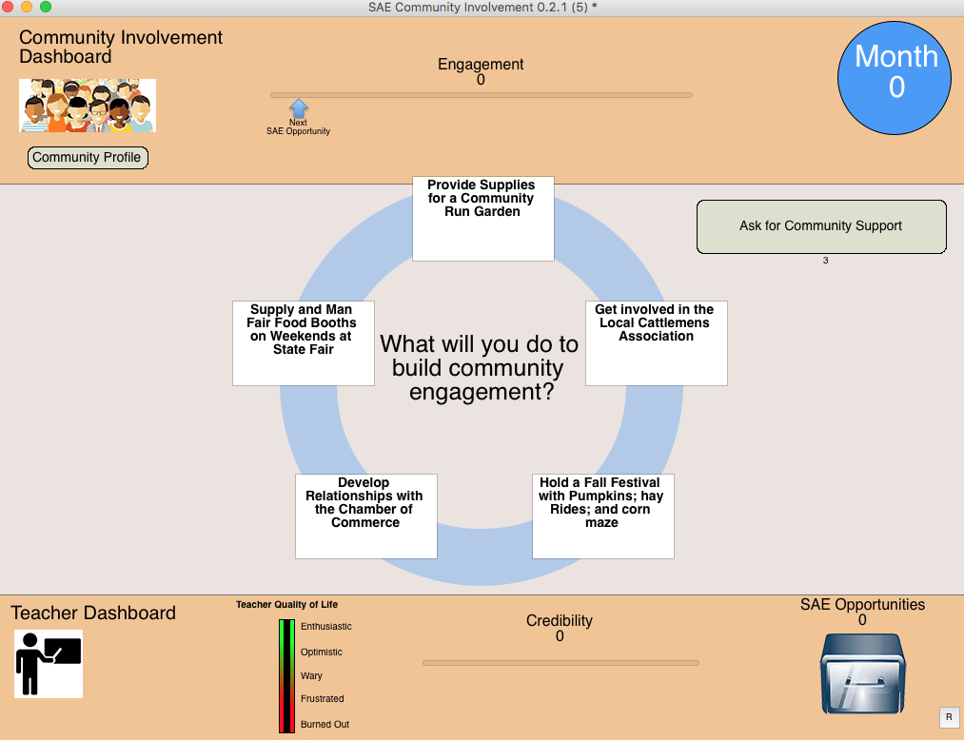

The goal of the game players is to collect a certain number of SAE Opportunities by creating engagement in the community. By clicking on the community support button, teachers are provided with some information to aid in their decision making process. Teachers are allowed to click this button only three times, so they are advised to use this feature sparingly. If the button is exhausted, it can be refreshed once the user has created SAE opportunities. Teachers must proceed in choosing one of five options provided in answering the question mentioned above. Each option is rated with points attached to it. The higher the points, the more credibility increases, and an SAE opportunity can be awarded. The teacher’s quality of life, engagement meter and community support (if below three) increases. The game is then over once the teacher reaches a time limit of fifteen simulated months. However, if the teacher continuously selects options with low points and depletes community support, the game ends prematurely. This translates to the teacher reaching a point of burn out. At the end of the game, the teacher is provided with a usage summary. It is noted that the game is currently a static application, and it does not seek external data from a database. This may be a factor to consider for the future.

Context
The e-learning game is made available online and asynchronously. Some of the contextual factors that may influence the implementation and effectiveness of the game include: teachers having access to a computer with the Internet to complete the game within the required timeframe, the availability (or lack thereof) of an onsite person of contact for clarification if needed, and teachers having the time in their busy schedules to participate in the game.

Population and Needs
The target population for the e-learning game is middle- and high-school agriculture teachers in Georgia. The game attempts to address the need for knowledge retention for SAE participants, self-efficacy in supervising SAE experiences, and decreasing burnout.

Age and Phase
The development stage of the e-learning game prototype began in the spring of 2017. A pilot test was done in the fall of 2017, and this resulted in a revised prototype. The beta version will be further revised. Therefore, although the game has undergone some alpha testing, it is in the middle of development. The implementation phase is expected to occur in fall of 2018.

Table 2. Logic Model
Resources/ Inputs | Activities | Outputs | Short-Term Outcomes | Long-Term Outcomes
Grant provided by USDA/NIFA for the development and implementation of Treasure SAE Program  Project team members with necessary expertise:  Agricultural education, teacher education, elearning design, instructional design  Computers with internet and programming software access | Collaboration between the Treasure SAE team and middle- and high-school agricultural teachers to discuss the problem and a possible solution  Research by stakeholders on multiple communities for SAE programs, effective methods of content presentation, and best available resources to assist teachers  The use of instructional design process model and learning theories in the development, evaluation, and revision of the e-learning game | E-learning game prototype developed to meet the needs of Treasure SAE Program  Agriculture teachers’ SAE game play | Increase in agriculture teachers’ knowledge retention and self-efficacy in supervising an SAE project  Effective usability of the game in terms of the functionality, aesthetics, engagement, and support for needed assistance  Decrease in burnout among agriculture teachers | Grant results dissemination  Increase in the ability of agriculture teachers to independently establish and maintain community partnerships, without experiencing burnout

Evaluation Questions
Armed with a full understanding of the time and resource challenges faced by agricultural literacy teachers throughout the country, this evaluation plan is focused on improving the TREASURE SAE game by studying the visual design and general attractiveness, the potential for knowledge retention and transfer to the performance context, and the self-efficacy of the learners after having played the game. This is a formative evaluation that focuses on aspects directly affecting the user experience, while also addressing the overall educational effectiveness. The following overarching questions compose the framework for our evaluation instruments, data gathering, and, ultimately, data analysis.

Questions of Efficacy:
Is the game relevant to the Target Learners (TL) professional responsibilities? (Learn & Apply)
Does the TL find immediate value in the teaching points?
Does the TL find new value when playing the game repeatedly?
Does the game provide varied scenarios; too few or too many?
Are scenarios practical and relevant?
Does the game build the self-efficacy of the TL in creating SAE opportunities in their respective communities?

Questions of Usability: (Playing the Game)
Is the game designed well?
Is the game interface intuitive to allow game players focus on the content?
Are reasonable and applicable explanations provided?
Do the aesthetics add or detract from the experience?
Does the overall “look & feel” foster a sense of professional trust?
Are gaming instructions and directions easy to follow?

Questions of Technical Stability: (Programming)
Is the game well put together?
Is the game stable from a technical standpoint?
Is the game accessible via multiple platforms (Mac, PC, Mobile)?
Is the game 508 compliant?
Is the game easy to acquire/install/update?
Is there a technical support system available to users?

Open-Ended Questions:
What would make the game a more valuable experience?
What aspects of the game are specifically enjoyable or useful?

Table 3. Focus Areas, Questions, Design, and Rationale of Your Evaluation

Stakeholders | Stakeholder Needs | Evaluation Focus Areas |  | 3-5 Evaluation Questions | Evaluation Design | Evaluation Design Rationale
Dr. Rubenstein and the grant team | The efficacy of the e-learning game as it relates to the goals of the grant | Implementation and outcomes | Does the TL find immediate value in the teaching points?  Does the TL find new value when playing the game repeatedly?  Does the game build the confidences of the TL enough to successfully re-create SAE opportunities in their respective communities? |  | Mixed methods | Learner interviews will be combined with quantitative data collection tools to provide a descriptive report on the usability and effectiveness of the game. Such qualitative data may be used in publicity, grant reporting, or future grant applications.
Dr. Rieber | Data that inform revisions regarding the technical development and overall usability | Context and implementation | Is the game intuitive enough to focus on the content?  Is the game accessible via multiple platforms (Mac, PC, Mobile)?  Is the game 508 compliant? |  | Quantitative | Data regarding the technical development and usability will be collected using a checklist with scales that measure both severity and extensiveness, in order to facilitate analysis that will enable prioritization of revisions
Dr. Newberry | The usability and efficacy of the game; as subject matter expert, subject-specific areas for improvement | Implementation and outcomes | Does the game provide varied scenarios; too few or too many?  Are scenarios practical and relevant?  Does the game build the confidences of the TL enough to successfully re-create SAE opportunities in their respective communities? |  | Mixed methods | Learner interviews will be combined with quantitative data collection tools to provide a descriptive report on the usability and effectiveness of the game. Such qualitative data may be used in publicity, grant reporting, or future grant applications.
Stakeholders | Stakeholder Needs | Evaluation Focus Areas | 3-5 Evaluation Questions |  | Evaluation Design | Evaluation Design Rationale
Pre-service Agriculture Teachers | The usability and effectiveness of the game | Implementation and outcomes | What would make the game a more valuable experience?  What aspects of the game are specifically enjoyable or useful?  What aspects of the game increase your confidence in supervising SAEs? |  | Mixed methods | Learner interviews will provide the grant team and Dr. Newberry with descriptive data, which will capture the full range and subtleties of the learners’ experience.

Data Collection and Analysis Plan
The team evaluating the TREASURE SAE game will employ a mixed methods approach with the goal of acquiring varied quantitative and qualitative data to develop a comprehensive and informative evaluation report. This approach will allow for the overlap of questions to ensure the evaluation is thorough and comprehensive, using both opinions and metrics derived from experts and—to the extent possible—target learners, via multiple data collection instruments and methods.

Expert Review
We will identify three industry experts in the fields of instructional design, visual design, and technical review/quality control. Two of these experts are graduate students with the Learning, Design, and Technology Program at the University of Georgia and possess either advanced degrees or significant industry experience. The technical reviewer/quality control specialist has yet to be defined and may not be utilized if an appropriate candidate is not identified.

Heuristic principles, based on the work of Dr. Thomas Reeves (Appendix A), will be repurposed as Google Forms to guide the experts in performing their assessments. Representing ordinal scales of measurement, the forms will align questions to specific principles with a corresponding principle explanation. These questions are included below. In addition to providing the ordinal rankings on both severity and extensiveness of each issue, the experts will also be given an opportunity to provide general written or oral commentary.

The experts will be provided access to the TREASURE SAE game and the instruments of review and will be required to complete the evaluation in a to-be-determined timeframe. The results will be provided via email and survey results.
Human resource constraints may impact the reliability of the expert evaluations, in that only one visual design expert and one instructional design expert are available. To partially address this, a member of the evaluation team will check each expert reviewer’s survey for internal consistency across similar items, and will address any concerns with the expert.

Learner Surveys
The learners are a focal point of this evaluation, and as a result, we have designed instruments to capture information related to both usability and self-efficacy. Learners will be identified by the TREASURE SAE stakeholders and will be typical of the target audience of agricultural literacy teachers at the middle- and high-school levels. They will be presented with the Online Survey in a to-be determined timeframe by the TREASURE SAE stakeholders.

To complete the process, the learners will be provided a Google Form Online Survey (Appendix B) to complete as they progress through the game. (A link to the survey can also be found here.) The survey was adapted from Kim, et. al, Studying the usability of an intervention to promote teacher's use of robotics in STEM education. This survey provides the opportunity for the collection of both qualitative and quantitative data, allowing for scored numerical data to identify numerical trends as well as opinion-based analysis to be compared to the expert analysis.

Learner Interviews
Recent learners and learners with historical knowledge identified by the stakeholders will be asked to participate in semi-structured interviews that will describe aspects of their experience—either positive or negative—that shaped their opinions of the game. Focusing exclusively on qualitative data, these interviews will collect personal opinions. Suggestions for improvements will be consolidated for comparison with data collected in the expert review.

These interviews will be conducted over the phone or via an internet-based video teleconference. The interviewers will utilize a set of questions to guide the interview; however, the interviewer will not be required to cover all topic areas. The interviewer should intuitively move the interview in response to the learners’ expressed areas of interest, as areas of focus are uncovered during the course of the interview. This will facilitate the most constructive and thoughtful opinions.

Recording interviews and having two evaluators review and code the data will increase the validity of the evaluation. Inter-rater reliability will be ensured by comparing two evaluators’ coding of the data.

Table 4. Mixed Methods Matrix
 | Is the game relevant to the Target Learners’ professional responsibilities? (Learn & Apply) | Is the game designed well? | Is the game well put together? | What would make the game a more valuable experience? | What aspects of the game are specifically enjoyable or useful?
Expert Reviews |  | X | X | X
Learner Surveys | X | X | X | X | X
Learner Interviews |  |  |  | X | X

Table 5. Evaluation Data Collection and Analysis Plan
3-5 Evaluation Questions | Data Collection Method | Data Source | Activities | Data Analysis
Is the game intuitive enough to focus on the content?  Is the game accessible via multiple platforms (Mac, PC, Mobile)?  Is the game 508 compliant? | Expert Survey | Google Forms | Sharon Laidlaw will develop the protocols for expert evaluation.  Matthew Whittlesey will complete the expert evaluation of visual design.  Sharon Laidlaw will complete the expert evaluation of instructional design.  The technical reviewer has yet to be determined.  Matthew Whittlesey will compile and clean data in a spreadsheet. | Sharon Laidlaw will check both survey responses for internal consistency and will use spreadsheet formulae to analyze the data for presentation to stakeholders.
How effective the learner can navigate around the game for task completion?  To what extent learners are allowed to interact with the website?  Can the user complete the task without technical difficulties?  To what degree are the teaching points valuable to you?  Are there too few or too many scenarios provided?  To what degree do you find the scenarios practical and relevant? | Learner Survey | Google Forms | Melanie Blackman and Stephanie Hulsey will prepare learner survey questions, and create form for dissemination to future learners. | Dr. Newberry will complete at a future date.
What would make the game a more valuable experience?  What aspects of the game are specifically enjoyable or useful?  What aspects of the game increase your confidence in supervising SAEs? | Learner Interview | Interview Protocol | Danielle Travis will develop an appropriate interview protocol and draft learner interview questions. Learner interviews to be completed at a later date by Dr. Newberry. | Sharon Laidlaw will use a grounded theory approach to extract codes from gathered qualitative data and analyze the results. Both Danielle Travis and Matthew Whittlesey will code the data, in order to improve credibility. Peer debriefing will further increase validity.

Logistics and Timeline
The evaluation team began working with the client in mid-February, with the first meeting on client needs occurring February 22. Upon learning about the project from the client, Dr. Newberry, the evaluation team began outlining a path to completion. (See chart below for task list, team member responsible, and delivery dates.)

Client Needs Assessment
Task to be completed | Team Member Responsible | Date Due
Schedule Initial Client Meeting | Danielle | Feb. 20
Client Interview Question Development | Matt | Feb. 21
Team Client Interview | Matt, Melanie, Danielle | Feb. 22

Following the establishment of the client’s needs and interests, the evaluation team developed a general plan to prepare for the project evaluation.

Evaluation Planning
Task to be completed | Team Member Responsible | Date Due
Intro & Background | Sharon | February 28
Evaluation Purpose | Danielle | February 28
Stakeholders | Danielle | February 28
Logic Model | Melanie | February 28
Evaluation Questions | Matt | February 28
Expert Review Data Collection & Analysis Plan | Matt | February 28
Learner Survey Data Collection & Analysis Plan | Melanie | February 28
Learner Interview Data Collection & Analysis Plan | Danielle | February 28
Logistics & Timeline | Stephanie | March 1
Evaluation Budget | Stephanie | March 1
Total Plan Review & Formatting | Sharon | March 4

Upon creation of the plan, the team set to work creating instruments for each area of the evaluation. The three-tiered evaluation plan is outlined below.

Expert Review:
Develop Expert Review Instrument | Matt & Sharon | March 15
Perform Evaluation | Matt & Sharon | March 25
Write up Results | Matt & Sharon | April 8
Learner Survey:
Develop Learner Survey Form | Melanie & Stephanie | March 15
Write up Procedure | Melanie & Stephanie | March 15
Learner Interview:
Develop Learner Interview Instrument | Danielle | March 15
Write up Procedure | Danielle | March 15

After all evaluation activities have been completed, a final evaluation report is to be delivered to the client in late April. In early April, the evaluation team will present the evaluation to peers for final feedback before returning to client.

Evaluation Budget (Not to be billed to the client but just for his information)
According to the National Science Foundation, it is expected that 5-10% of total program cost should be reserved for evaluation. The TREASURE SAE project has been funded at $143,885. Evaluation costs could range from $7,195 to $14,390. For the purposes of this project, we estimate costs with each expert evaluators’ hourly rate at $50 per hour.

Evaluation Line Items:
Research & Needs Assessment | 3 experts at 4 hours | $600
Development of Evaluation Plans & Evaluation Instruments | 5 experts at 12 hours each | $3,000
Expert Evaluation Completion | 2 experts at 5 hours each | $500
Data Collection & Analysis | 2 experts at 5 hours each | $500
Preparation of Report to Client | 5 experts at 5 hours each | $1,250
Total Evaluation Cost Estimate: $5,850

Appendix A: Heuristic Expert Evaluation

Topic | Guiding Questions | Indicator | Standards | Data Collection | Timeline
Visibility of system status | The e-learning program keeps the learner informed about what is happening, through appropriate feedback within reasonable time. | 0 - 4 Scale (from "This is not a problem" to "Usability catastrophe; imperative to fix before this product is released") | Sliding scale allows for the client to determine urgency/ prioritization of revisions | GoogleForms | Post-Survey
Match between system and the real world | The e-learning program’s interface employs words, phrases and concepts familiar to the learner, rather than system-oriented terms. Wherever possible, the e-learning program utilizes real-world conventions that make information appear in a natural and logical order. | 0 - 4 Scale (from "This is not a problem" to "Usability catastrophe; imperative to fix before this product is released") | Sliding scale allows for the client to determine urgency/ prioritization of revisions | GoogleForms | Post-Survey
User control and freedom | The e-learning program allows the learner to recover from input mistakes and provides a clearly marked “emergency exit” to leave an unwanted state without having to go through an extended dialogue. | 0 - 4 Scale (from "This is not a problem" to "Usability catastrophe; imperative to fix before this product is released") | Sliding scale allows for the client to determine urgency/ prioritization of revisions | GoogleForms | Post-Survey
Consistency and standards | The e-learning program is consistent in its use of different words, situations, or actions and it adheres to general software and platform conventions. | 0 - 4 Scale (from "This is not a problem" to "Usability catastrophe; imperative to fix before this product is released") | Sliding scale allows for the client to determine urgency/ prioritization of revisions | GoogleForms | Post-Survey
Error prevention | The e-learning program is carefully designed to prevent common problems from occurring in the first place. | 0 - 4 Scale (from "This is not a problem" to "Usability catastrophe; imperative to fix before this product is released") | Sliding scale allows for the client to determine urgency/ prioritization of revisions | GoogleForms | Post-Survey
Recognition rather than recall | The e-learning program makes objects, actions, and options visible so that the user does not have to remember information from one part of the program to another. Instructions for use of the program are visible or easily retrievable. | 0 - 4 Scale (from "This is not a problem" to "Usability catastrophe; imperative to fix before this product is released") | Sliding scale allows for the client to determine urgency/ prioritization of revisions | GoogleForms | Post-Survey
Flexibility and efficiency of use | The e-learning program is designed to speed up interactions for the experienced learner, but also cater to the needs of the inexperienced learner. | 0 - 4 Scale (from "This is not a problem" to "Usability catastrophe; imperative to fix before this product is released") | Sliding scale allows for the client to determine urgency/ prioritization of revisions | GoogleForms | Post-Survey
Aesthetic and minimalist design | Screen displays do not contain information that is irrelevant, and “bells and whistles” are not gratuitously added to the e-learning program. | 0 - 4 Scale (from "This is not a problem" to "Usability catastrophe; imperative to fix before this product is released") | Sliding scale allows for the client to determine urgency/ prioritization of revisions | GoogleForms | Post-Survey
Help users recognize, diagnose, and recover from errors | The e-learning program expresses error messages in plain language (without programmer codes), precisely indicates the problem, and constructively suggests a solution. | 0 - 4 Scale (from "This is not a problem" to "Usability catastrophe; imperative to fix before this product is released") | Sliding scale allows for the client to determine urgency/ prioritization of revisions | GoogleForms | Post-Survey
Help and documentation | When it is absolutely necessary to provide help and documentation, the e-learning program provides any such information in a manner that is easy to search. Any help provided is focused on the learner's task, lists concrete steps to be carried out, and is not be too large. | 0 - 4 Scale (from "This is not a problem" to "Usability catastrophe; imperative to fix before this product is released") | Sliding scale allows for the client to determine urgency/ prioritization of revisions | GoogleForms | Post-Survey
Interactivity | The e-learning program provides content-related interactions and tasks that support meaningful learning. | 0 - 4 Scale (from "This is not a problem" to "Usability catastrophe; imperative to fix before this product is released") | Sliding scale allows for the client to determine urgency/ prioritization of revisions | GoogleForms | Post-Survey
Message Design | The e-learning program presents information in accord with sound principles of information-processing theory. | 0 - 4 Scale (from "This is not a problem" to "Usability catastrophe; imperative to fix before this product is released") | Sliding scale allows for the client to determine urgency/ prioritization of revisions | GoogleForms | Post-Survey
Learning Design | The interactions in the e-learning program have been designed in accord with sound principles of learning theory. | 0 - 4 Scale (from "This is not a problem" to "Usability catastrophe; imperative to fix before this product is released") | Sliding scale allows for the client to determine urgency/ prioritization of revisions | GoogleForms | Post-Survey
Assessment | The e-learning program provides assessment opportunities that are aligned with the program objectives and content. | 0 - 4 Scale (from "This is not a problem" to "Usability catastrophe; imperative to fix before this product is released") | Sliding scale allows for the client to determine urgency/ prioritization of revisions | GoogleForms | Post-Survey
Media Integration | The inclusion of media in the e-learning program serves clear pedagogical and/or motivational purposes. | 0 - 4 Scale (from "This is not a problem" to "Usability catastrophe; imperative to fix before this product is released") | Sliding scale allows for the client to determine urgency/ prioritization of revisions | GoogleForms | Post-Survey
Resources | The e-learning program provides access to all the resources necessary to support effective learning. | 0 - 4 Scale (from "This is not a problem" to "Usability catastrophe; imperative to fix before this product is released") | Sliding scale allows for the client to determine urgency/ prioritization of revisions | GoogleForms | Post-Survey
Performance Support Tools | The e-learning program provides access to performance support tools that are relevant to the content and objectives. | 0 - 4 Scale (from "This is not a problem" to "Usability catastrophe; imperative to fix before this product is released") | Sliding scale allows for the client to determine urgency/ prioritization of revisions | GoogleForms | Post-Survey
Learning Management | The e-learning program enables learners to monitor their progress through the material. | 0 - 4 Scale (from "This is not a problem" to "Usability catastrophe; imperative to fix before this product is released") | Sliding scale allows for the client to determine urgency/ prioritization of revisions | GoogleForms | Post-Survey
Feedback | The e-learning program provides feedback that is contextual and relevant to the problem or task in which the learner is engaged. | 0 - 4 Scale (from "This is not a problem" to "Usability catastrophe; imperative to fix before this product is released") | Sliding scale allows for the client to determine urgency/ prioritization of revisions | GoogleForms | Post-Survey
Content | The content of the e-learning program is organized in a manner than is clear to the learner. | 0 - 4 Scale (from "This is not a problem" to "Usability catastrophe; imperative to fix before this product is released") | Sliding scale allows for the client to determine urgency/ prioritization of revisions | GoogleForms | Post-Survey

Appendix B: Learner Survey

Topic | Question | Indicator | Standards | Data Collection | Timeline
Navigation | There is always a clear link to the homepage. | 1 - 5 Scale (from "Strongly Disagree" to "Strongly Agree") | 80% respond "Agree" or "Strongly Agree" | GoogleForms | Post-Survey
Navigation | I can easily find what I'm looking for. | 1 - 5 Scale (from "Strongly Disagree" to "Strongly Agree") | 80% respond "Agree" or "Strongly Agree" | GoogleForms | Post-Survey
Navigation | The buttons have clear labels. | 1 - 5 Scale (from "Strongly Disagree" to "Strongly Agree") | 80% respond "Agree" or "Strongly Agree" | GoogleForms | Post-Survey
Navigation | All links in the site are working. | 1 - 5 Scale (from "Strongly Disagree" to "Strongly Agree") | 80% respond "Agree" or "Strongly Agree" | GoogleForms | Post-Survey
Navigation | The site allowed me to easily move whenever I wanted to go. | 1 - 5 Scale (from "Strongly Disagree" to "Strongly Agree") | 80% respond "Agree" or "Strongly Agree" | GoogleForms | Post-Survey
Navigation | Icons and images fully represented what they were supposed to do. | 1 - 5 Scale (from "Strongly Disagree" to "Strongly Agree") | 80% respond "Agree" or "Strongly Agree" | GoogleForms | Post-Survey
Visual Clarity | The layout is clear. | 1 - 5 Scale (from "Strongly Disagree" to "Strongly Agree") | 80% respond "Agree" or "Strongly Agree" | GoogleForms | Post-Survey
Visual Clarity | Texts are easy to read (both font style and size). | 1 - 5 Scale (from "Strongly Disagree" to "Strongly Agree") | 80% respond "Agree" or "Strongly Agree" | GoogleForms | Post-Survey
Visual Clarity | There is adequate text-to-background contrast. | 1 - 5 Scale (from "Strongly Disagree" to "Strongly Agree") | 80% respond "Agree" or "Strongly Agree" | GoogleForms | Post-Survey
Content | The major headings are clear and descriptive. | 1 - 5 Scale (from "Strongly Disagree" to "Strongly Agree") | 80% respond "Agree" or "Strongly Agree" | GoogleForms | Post-Survey
Content | The use of terminology and vocabulary were appropriate for intended users. | 1 - 5 Scale (from "Strongly Disagree" to "Strongly Agree") | 80% respond "Agree" or "Strongly Agree" | GoogleForms | Post-Survey
Interactivity | The site contained factors to attract my attention. | 1 - 5 Scale (from "Strongly Disagree" to "Strongly Agree") | 80% respond "Agree" or "Strongly Agree" | GoogleForms | Post-Survey
Interactivity | The site well showed what's new or important on visible places. | 1 - 5 Scale (from "Strongly Disagree" to "Strongly Agree") | 80% respond "Agree" or "Strongly Agree" | GoogleForms | Post-Survey
Attractiveness | The site reflected recent trends in terms of its' design. | 1 - 5 Scale (from "Strongly Disagree" to "Strongly Agree") | 80% respond "Agree" or "Strongly Agree" | GoogleForms | Post-Survey
Attractiveness | The site's design well represented what it suppose to provide. | 1 - 5 Scale (from "Strongly Disagree" to "Strongly Agree") | 80% respond "Agree" or "Strongly Agree" | GoogleForms | Post-Survey
Attractiveness | The site has unique attributes compared to other sites for a similar purpose. | 1 - 5 Scale (from "Strongly Disagree" to "Strongly Agree") | 80% respond "Agree" or "Strongly Agree" | GoogleForms | Post-Survey
User Support | I was able to get adequate support when having trouble with using the site. | 1 - 5 Scale (from "Strongly Disagree" to "Strongly Agree") | 80% respond "Agree" or "Strongly Agree" | GoogleForms | Post-Survey
Helpfulness | The site seemed to fully function as intended. | 1 - 5 Scale (from "Strongly Disagree" to "Strongly Agree") | 80% respond "Agree" or "Strongly Agree" | GoogleForms | Post-Survey
Helpfulness | I got enough information I needed. | 1 - 5 Scale (from "Strongly Disagree" to "Strongly Agree") | 80% respond "Agree" or "Strongly Agree" | GoogleForms | Post-Survey
Learnability | I could easily get familiar with functions and structures of the site. | 1 - 5 Scale (from "Strongly Disagree" to "Strongly Agree") | 80% respond "Agree" or "Strongly Agree" | GoogleForms | Post-Survey
Technical Function | There was no technical problem while surfing on the site. | 1 - 5 Scale (from "Strongly Disagree" to "Strongly Agree") | 80% respond "Agree" or "Strongly Agree" | GoogleForms | Post-Survey
Technical Function | There was no delay when trying to load pages. | 1 - 5 Scale (from "Strongly Disagree" to "Strongly Agree") | 80% respond "Agree" or "Strongly Agree" | GoogleForms | Post-Survey
Exchange- ability | I could easily download files. | 1 - 5 Scale (from "Strongly Disagree" to "Strongly Agree") | 80% respond "Agree" or "Strongly Agree" | GoogleForms | Post-Survey
Non Redundancy | Menus, categories, information, or pages didn't overlap with others. | 1 - 5 Scale (from "Strongly Disagree" to "Strongly Agree") | 80% respond "Agree" or "Strongly Agree" | GoogleForms | Post-Survey
General | Was there something missing you were expecting to see? If there was, what was it? | Long Answer | 80% active responding | GoogleForms | Post-Survey

